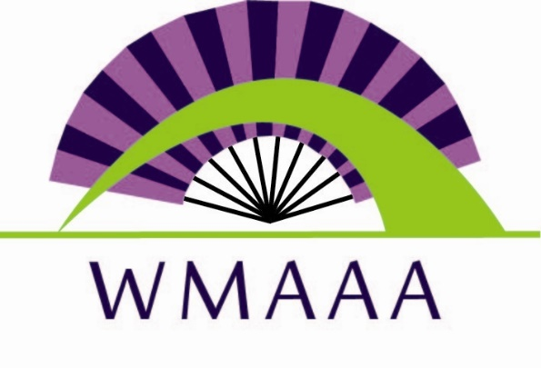
West Michigan Asian American Association
Your Invitation to the 7th Annual Asian Gala
Thursday, March 17, 2016
GOEI Center
818 Butterworth SW, Grand Rapids MI 49504

5:30 p.m. Hors d’oeuvres
6:15 p.m. Program
7:15 p.m. Networking and Strolling
Taste of Asian Foods

Individual Admission: $50
(Business Casual or Ethnic Attire)

Join us for the opportunity to connect Asian leaders and professionals with the greater West Michigan community. Proceeds from this event help WMAAA meet the needs of our Asian communities in West Michigan. Sponsorship opportunities are available at different levels. Advertisement space in event brochure is available. Contact Minnie Morey at info@wm-aaa.org or 616-481-6194 for details.
Make reservation by sending your check of $50 to the following address by March 1, 2016
WMAAA
PO Box 230432
Grand Rapids MI 49523

