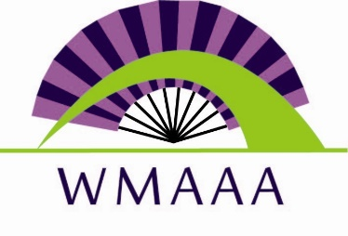
HAAP West Michigan Asian American Association

AFFORDABLE CARE ACT ENROLLMENT Minnie Morey 616-481-6194
Marketplace Insurance or Krishna Bista (Nepal) 616-329-9600
Healthy Michigan Plan Thuhuong Tran (Vietnamese) 616-540-7905
Gui Xiu Xie (Chinese) 616-797-8076

HEALTHY ASIAN AMERICAN PROJECT
(In Association With West Michigan Asian American Association)
PO Box 230432
Grand Rapids MI 49523
Email: info@wm-aaa.org
Phone: 616-481-6194

